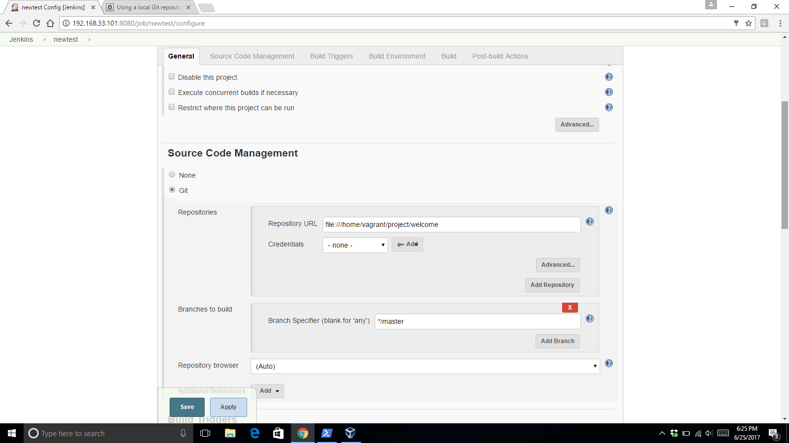

To use local git repo enter the file path as the URL for GIT repository.

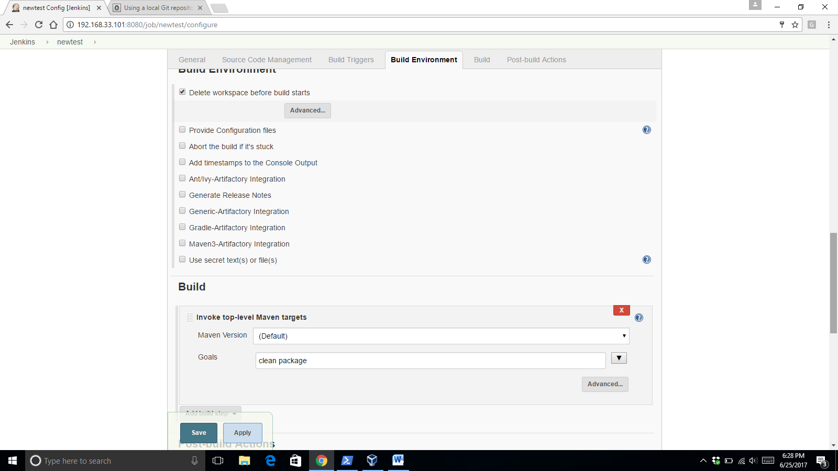

Select maven build action for building the code.

Make sure the [file:///](NULL) declaration is used for git local repo.